**TABLE CREATION**

CREATE TABLE ATTACK_TYPE (

ATTACK_TYPE_ID VARCHAR(20) NOT NULL,

TYPE_NAME VARCHAR(50) NOT NULL,

CONSTRAINT ATTACK_TYPE_PK PRIMARY KEY (ATTACK_TYPE_ID));

CREATE TABLE ORGANIZATION (

ORG_ID VARCHAR(20) NOT NULL,

ORG_NAME VARCHAR(100) NOT NULL,

LOCATION VARCHAR(100),

CONSTRAINT ORGANIZATION_PK PRIMARY KEY (ORG_ID));

CREATE TABLE THREAT (

THREAT_ID INT NOT NULL,

THREAT_NAME VARCHAR(100) NOT NULL,

SEVERITY_LEVEL VARCHAR(20),

DATE_OCCURRED DATE,

ATTACK_TYPE_ID INT,

CONSTRAINT THREAT_PK PRIMARY KEY (THREAT_ID),

CONSTRAINT THREAT_FK_ATTACK_TYPE FOREIGN KEY (ATTACK_TYPE_ID) REFERENCES ATTACK_TYPE(ATTACK_TYPE_ID));

CREATE TABLE INCIDENT_RESPONSE_TEAM (

TEAM_ID VARCHAR(20) NOT NULL,

TEAM_NAME VARCHAR(100) NOT NULL,

CONTACT_INFO VARCHAR(100),

CONSTRAINT INCIDENT_RESPONSE_TEAM_PK PRIMARY KEY (TEAM_ID));

CREATE TABLE THREAT_SOURCE (

SOURCE_ID VARCHAR(20) NOT NULL,

SOURCE_TYPE VARCHAR(50) NOT NULL,

SOURCE_DESCRIPTION TEXT,

CONSTRAINT THREAT_SOURCE_PK PRIMARY KEY (SOURCE_ID));

CREATE TABLE MITIGATION_ACTION (

MITIGATION_ID VARCHAR(20) NOT NULL,

ACTION_DESCRIPTION VARCHAR(255) NOT NULL,

DATE_IMPLEMENTED DATE,

CONSTRAINT MITIGATION_ACTION_PK PRIMARY KEY (MITIGATION_ID));

CREATE TABLE THREAT_IMPACT (

THREAT_ID INT,

ORG_ID VARCHAR(20),

IMPACT_LEVEL VARCHAR(50),

IMPACT_DATE DATE,

PRIMARY KEY (THREAT_ID, ORG_ID),

FOREIGN KEY (THREAT_ID) REFERENCES THREAT(THREAT_ID),

FOREIGN KEY (ORG_ID) REFERENCES ORGANIZATION(ORG_ID));

CREATE TABLE THREAT_MITIGATION (

THREAT_ID INT NOT NULL,

MITIGATION_ID VARCHAR(20) NOT NULL,

MITIGATION_STATUS VARCHAR(50),

REVIEW_DATE DATE,

CONSTRAINT THREAT_MITIGATION_PK PRIMARY KEY (THREAT_ID, MITIGATION_ID),

CONSTRAINT THREAT_MITIGATION_FK_THREAT FOREIGN KEY (THREAT_ID) REFERENCES THREAT(THREAT_ID),

CONSTRAINT THREAT_MITIGATION_FK_MITIGATION FOREIGN KEY (MITIGATION_ID) REFERENCES MITIGATION_ACTION(MITIGATION_ID));

**INSERT STATEMENTS**

INSERT INTO ATTACK_TYPE (ATTACK_TYPE_ID, TYPE_NAME) VALUES

('AT01', 'Phishing'),

('AT02', 'Malware'),

('AT03', 'Ransomware'),

('AT04', 'DDoS Attack'),

('AT05', 'Spyware'),

('AT06', 'Insider Threat'),

('AT07', 'SQL Injection'),

('AT08', 'Zero-Day Exploit');

INSERT INTO ORGANIZATION (ORG_ID, ORG_NAME, LOCATION) VALUES

('ORG001', 'TechCorp', 'New York'),

('ORG002', 'HealthInc', 'Los Angeles'),

('ORG003', 'EduNet', 'Chicago'),

('ORG004', 'BankSecure', 'San Francisco'),

('ORG005', 'RetailHub', 'Seattle'),

('ORG006', 'AutoDrive', 'Detroit'),

('ORG007', 'PharmaMed', 'Boston'),

('ORG008', 'EnergyGrid', 'Houston');

INSERT INTO THREAT (THREAT_ID, THREAT_NAME, SEVERITY_LEVEL, DATE_OCCURRED, ATTACK_TYPE_ID) VALUES

(101, 'Data Breach', 'High', '2024-01-15', 'AT01'),

(201, 'System Infection', 'Medium', '2024-02-20', 'AT02'),

(301, 'Ransom Attack', 'Critical', '2024-03-10', 'AT03'),

(401, 'Website Outage', 'Low', '2024-04-01', 'AT04'),

(501, 'Data Exfiltration', 'High', '2024-05-12', 'AT05'),

(601, 'Unauthorized Access', 'Medium', '2024-06-07', 'AT06'),

(701, 'Database Corruption', 'Critical', '2024-07-15', 'AT07'),

(801, 'Unknown Exploit', 'Critical', '2024-08-22', 'AT08');

INSERT INTO INCIDENT_RESPONSE_TEAM (TEAM_ID, TEAM_NAME, CONTACT_INFO) VALUES

('IRT01', 'Alpha Team', 'alpha@response.com'),

('IRT02', 'Bravo Squad', 'bravo@response.com'),

('IRT03', 'Charlie Unit', 'charlie@response.com'),

('IRT04', 'Delta Force', 'delta@response.com'),

('IRT05', 'Echo Crew', 'echo@response.com'),

('IRT06', 'Foxtrot Command', 'foxtrot@response.com'),

('IRT07', 'Golf Squad', 'golf@response.com'),

('IRT08', 'Hotel Division', 'hotel@response.com');

INSERT INTO THREAT_SOURCE (SOURCE_ID, SOURCE_TYPE, SOURCE_DESCRIPTION) VALUES

('SRC001', 'External', 'Originates from outside the organization'),

('SRC002', 'Internal', 'Originates from within the organization'),

('SRC003', 'Third-Party', 'Supplied by external vendors'),

('SRC004', 'Partner', 'Threat originates from business partners'),

('SRC005', 'Cloud', 'Threat arises from cloud services'),

('SRC006', 'Unknown', 'Source is unidentified'),

('SRC007', 'Nation-State', 'Government-backed threat actors'),

('SRC008', 'Hacktivist', 'Political or social activism threats');

INSERT INTO MITIGATION_ACTION (MITIGATION_ID, ACTION_DESCRIPTION, DATE_IMPLEMENTED) VALUES

('MA01', 'Apply Patch', '2024-01-16'),

('MA02', 'Isolate Affected Systems', '2024-02-22'),

('MA03', 'Pay Ransom', '2024-03-12'),

('MA04', 'Upgrade Firewall', '2024-04-05'),

('MA05', 'Conduct Audit', '2024-05-15'),

('MA06', 'Reset Credentials', '2024-06-10'),

('MA07', 'Monitor Traffic', '2024-07-18'),

('MA08', 'Deploy Backup', '2024-08-25');

INSERT INTO THREAT_IMPACT (THREAT_ID, ORG_ID, IMPACT_LEVEL, IMPACT_DATE) VALUES

(101, 'ORG001', 'Critical', '2024-01-16'),

(201, 'ORG002', 'Moderate', '2024-02-23'),

(301, 'ORG003', 'Severe', '2024-03-13'),

(401, 'ORG004', 'Low', '2024-04-10'),

(501, 'ORG005', 'High', '2024-05-20'),

(601, 'ORG006', 'Moderate', '2024-06-15'),

(701, 'ORG007', 'Critical', '2024-07-25'),

(801, 'ORG008', 'Severe', '2024-08-30');

INSERT INTO THREAT_MITIGATION (THREAT_ID, MITIGATION_ID, MITIGATION_STATUS, REVIEW_DATE) VALUES

(101, 'MA01', 'Completed', '2024-01-20'),

(201, 'MA02', 'In Progress', '2024-02-25'),

(301, 'MA03', 'Pending', NULL),

(401, 'MA04', 'Completed', '2024-04-15'),

(501, 'MA05', 'Pending', NULL),

(601, 'MA06', 'Completed', '2024-06-18'),

(701, 'MA07', 'In Progress', '2024-07-28'),

(801, 'MA08', 'Pending', NULL);

**TABLES – Screenshots**

**Attack_Type**

**Organization**

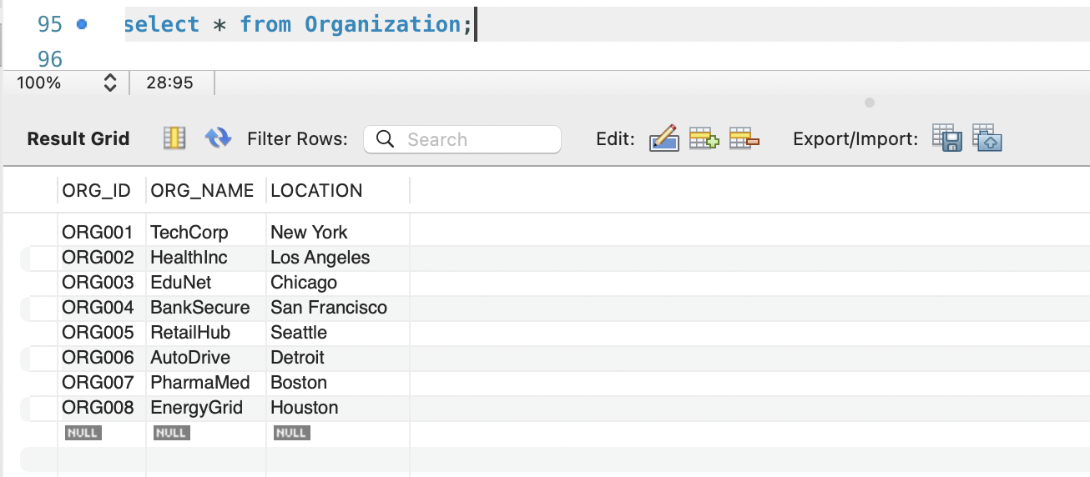

**Threat**

**Incident_response_team**

**Threat_source**

**Mitigation Action**

**Threat_Impact**

**Threat_Mitigation**

**QUERIES**

1. Display the total number of threats recorded in the system.

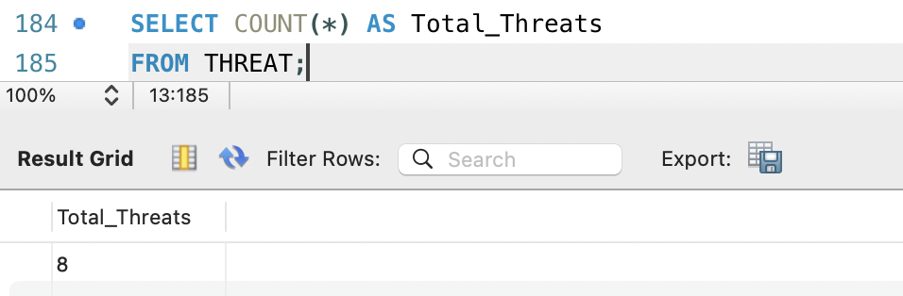

1. List Threats and Their Corresponding Attack Types

1. What threats impact organizations with a "High" severity level.

1. Show the number of threats associated with each attack type.

1. Display the mitigation status of threats along with the associated mitigation actions.

1. What are the severity levels by threat source, display the total threats by source and the percentage of critical threats.

1. Filter threats with a severity level of "High" or "Critical."

1. Display organizations impacted specifically by SQL Injection threats.

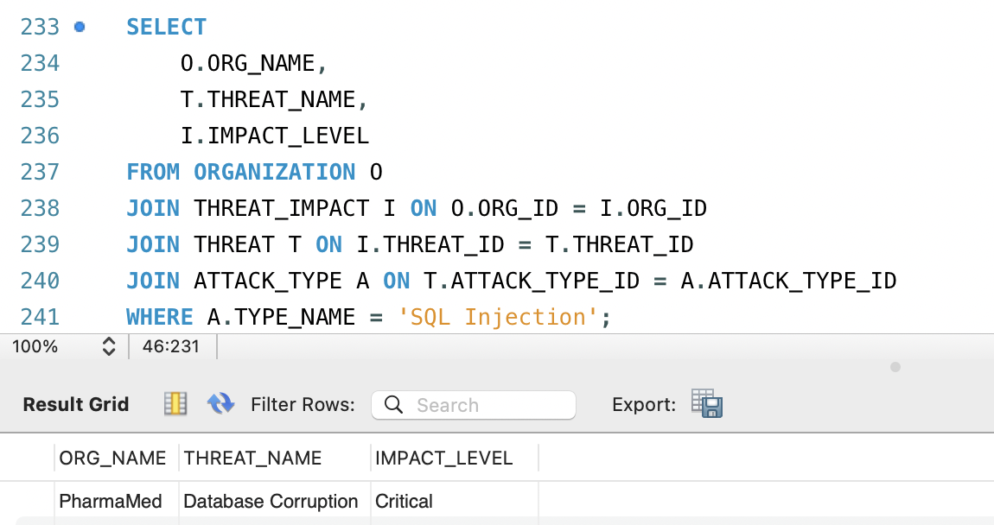

1. Identify the most common attack type in high-severity threats.

1. Provide details of threats with completed mitigation actions.

1. Show all threats, including those without matching attack types.

1. identify the organization most frequently impacted by high-impact threats

1. Display the total number of threats for each severity level.

1. Show the average number of threats impacting each organization.

1. Which organizations that have not been impacted by any threats.

1. What threats were mitigated after their occurrence date.

1. List organizations and how many threats have impacted them.

1. Show organizations in New York and the threats that have impacted them

1. Which threats that have been mitigated but not yet reviewed

1. Display the names of threats along with their corresponding attack types.

